Information Retrieval Using Excel

First: Quick Revision of Excel:
MS Excel, is a spreadsheet program represented by Microsoft within Microsoft Office Package. It is mainly used to arrange data into spreadsheets (tables), and apply several types of calculations on them. Also, Charts can be drawn on Excel using certain data.
In this course, we will use Excel 2010. The main elements of an Excel screen are:
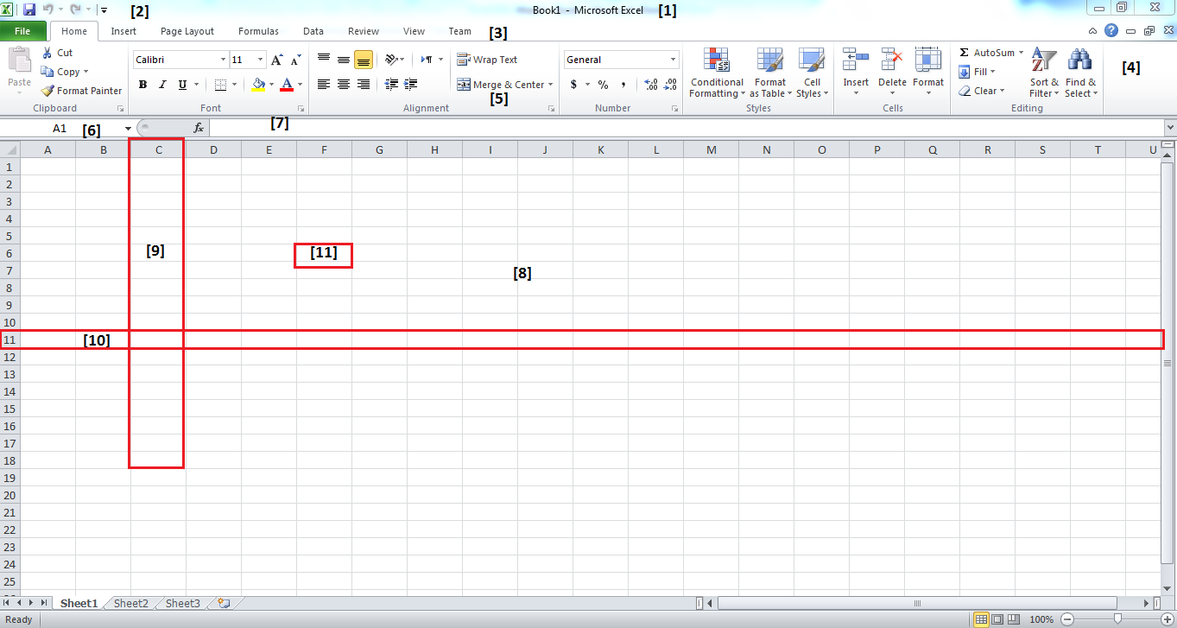
[1] Title bar: used to display the title of the Excel File
[2] Quick Access Toolbar: Displays several commands that are used more frequently by the user.
[3] Tabs: Each tab contains a ribbon with several commands.
[4] Ribbon: Each Ribbon contains several groups
[5] Group: Contains several commands that are related to each other.
[6] Namebox: displays the name of the selected cell or the first selected cell.
[7] Formula Bar: Here you can add formulas and/or functions to perform on your data.
[8] Worksheet (Sheet): is the main working area each sheet contains several cells.
[9] Column: Each column is named by a letter (or letters), and it contains cells.
[10] Row: Each row is named by a number, and it also contains cells.
[11] A cell: is an intersection between a row and a column. It is the most important component in the sheet, since a cell contains a value, or a forumula’s result.
A cell is named after both the column and the row it resides in, i.e. A cell in column C, and row 3 is called C3. This naming is important so that you can use the cell name in a formula.
Formulas:
You can add a formula in the Formula bar. But, first you have to select a certain cell first, and then insert a formula, the result of the formula will appear in the cell.
Any Formula should start with the symbol (=), if it is not proceeded with this symbol, it will be considered merely data. Check the following image:
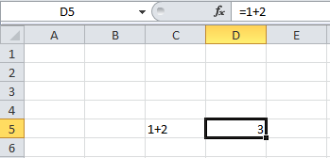
In cell C5, 1+2 is inserted, but it is not considered a formula, so it appears as is. While in cell D5, a formula is inserted as displayed, and its result (3) is shown in the cell.
In a formula you can use all types of mathematical operations, taking the precedence rules into consideration. You also can use brackets ().

Functions:
Functions are ready made formulas or programs that a user can use directly to perform certain task(s).
Functions are categorized into several categories according to their functionality.
You can find all function libraries in tab “Formula”
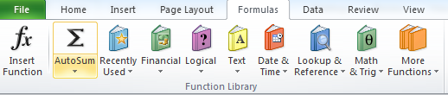
You also can use “Insert Function” button to search for a certain function and use it.
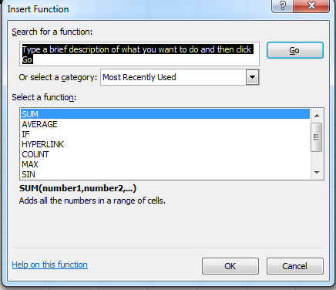
A function should be written in a certain syntax:
=function_name(parameters)
Parameters: are the values used by the function to find a result.
Examples:
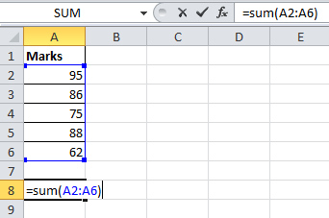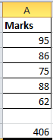

Second: Simple Searching Techniques on Excel
- Find and Replace:

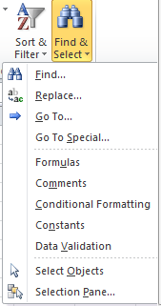
Find: is used to search for certain data within the file.
Replace: is used to search for certain data and change it with other data.

In the image below, we need to search for the name Mohammad:
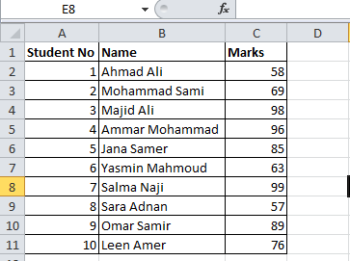
So, from Find option, the following screen will appear, and you place the text "Mohammad" in the textbox, as follows:
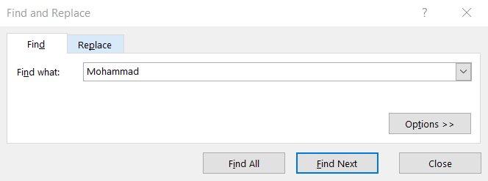
If Find All is pressed, the following will appear:
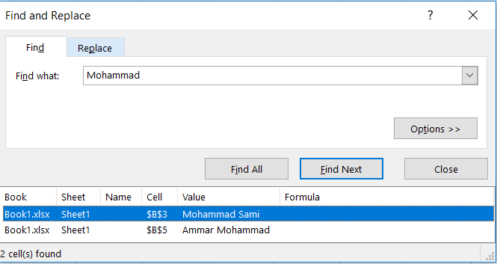
And when you click any of them, it will highlight the cell that contains this value.
If you press "Find Next", then at each press you will go to the next appearance of the text.
When you press "Options" further advanced options will appear:
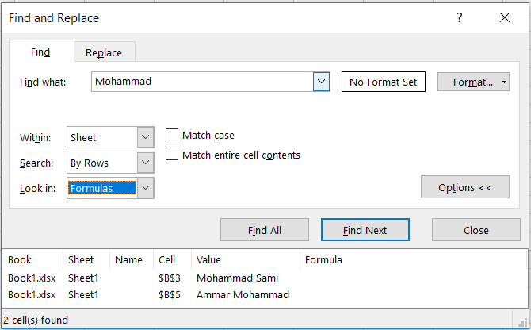
If you checked on "Match case" then Excel will search for the text at the same letter cases written.
For example:
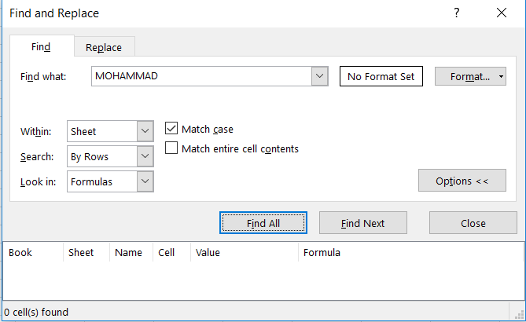
Here excel will search for the name "MOHAMMAD" written exactly in the same way entered. So, according to the data, no such text is found.
As for Replace:

It will display the same screen, but in "Replace" tab, and with one extra line
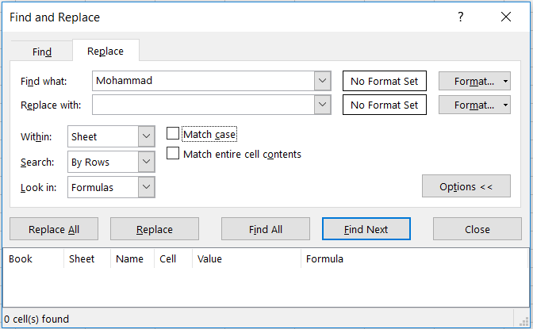
Here, you search for "Mohammad" and you can specify what text you need to replace it with.
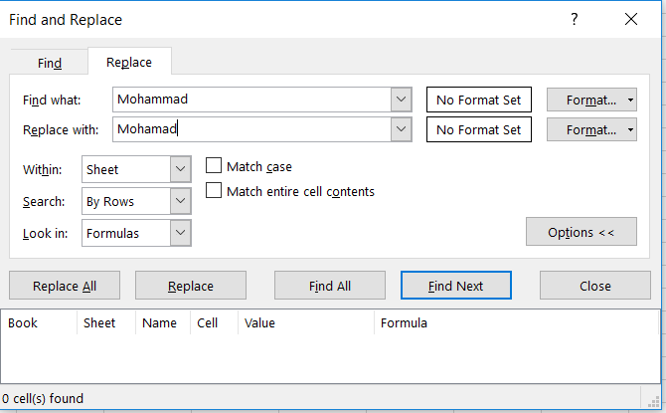
If "Replace" is pressed you will apply the replace one at a time. But, if "Replace All" is pressed, all occurrences of "Mohammad" will be replaced with "Mohamad".
Another option that can be used in both "Find" and "Replace" options, is the "Within", where you can search the text you need either in the current sheet, or in the whole workbook (all sheets in the workbook).
- Sorting:
Many times you may have large data that needs to be sorted according to certain column(s).

To apply sorting you have to select a cell in the column you want to sort by, then go to the icon.
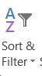

According to the selected cell's data type, the sorting options will differ. Like in the following examples:

Ex1: here the selection is on a cell that have a text value, so you will find the options will be sorting either from "A to Z" or from "Z to A". When any of these options is selected, the whole table is sorted according to this criterion.

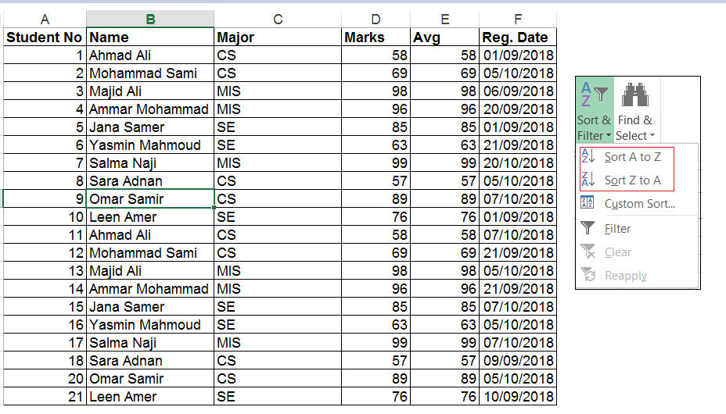
Ex2: here the selection is on a cell that have a number value, so you will find the options will be sorting either from "Smallest to Largest" or from "Largest to Smallest". When any of these options is selected, the whole table is sorted according to this criterion.

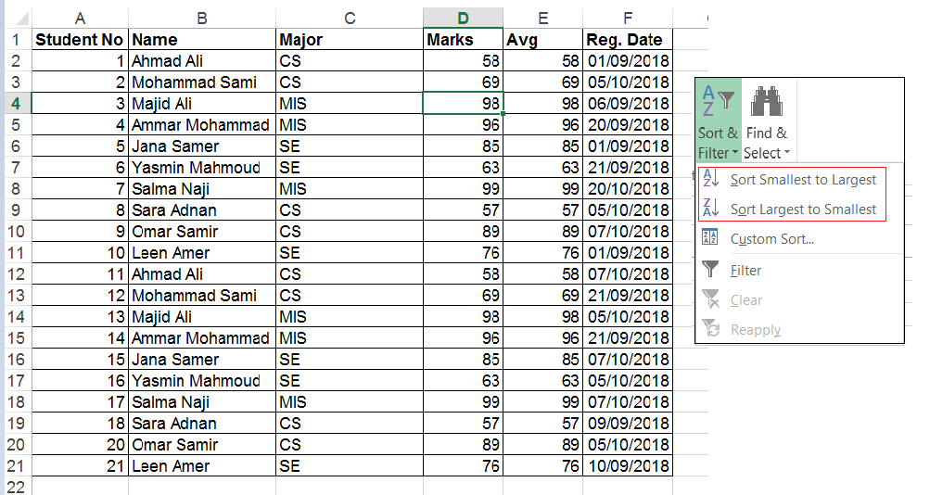

Ex3: here the selection is on a cell that have a number value, so you will find the options will be sorting either from "Oldest to Newest" or from "Newest to Oldest". When any of these options is selected, the whole table is sorted according to this criterion.
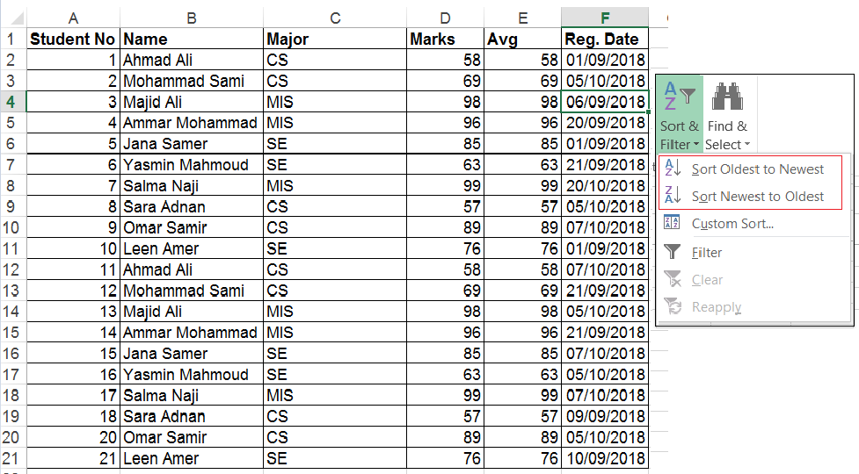
Sometimes you need to sort on several levels, for example sort on the Major (Level1), and for similar results sort on Marks (Level2). To do that, use "Custom Sort".
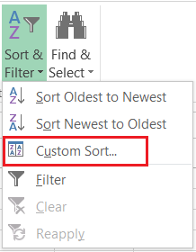

To apply the previous sorting (Major then Marks):
- Select "Custom Sort"
- The following dialogue will appear
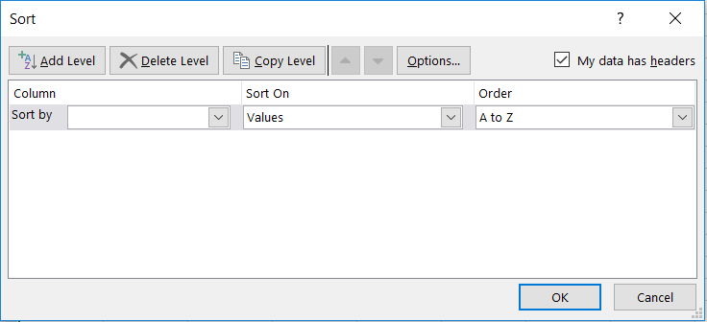

- In the first level select "Major"
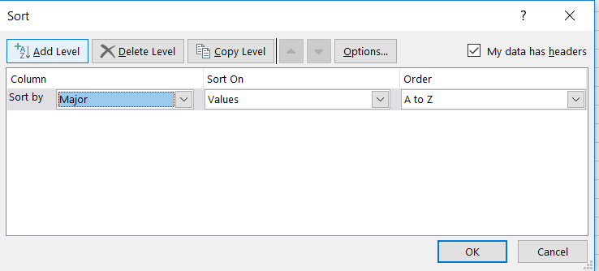
And again, you can choose to order from "A to Z" or "Z to A".
- To add a new level (Marks), press "Add Level"
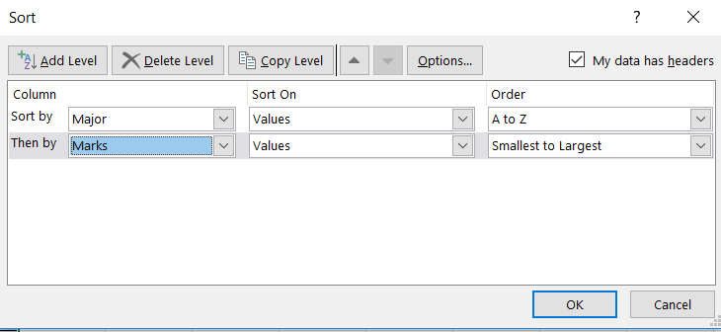
Also, here you can choose to order from "Smallest to Largest" or "Largest to Smallest".
- Press Ok and check the results:
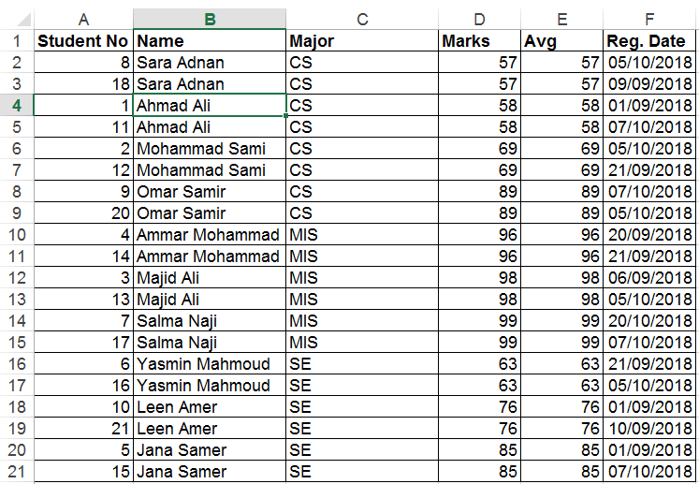
Check in the following image, how the Major is sorted first, but when for example there are several records with major "CS", the marks are sorted according to "Marks" and only within the "CS" students.
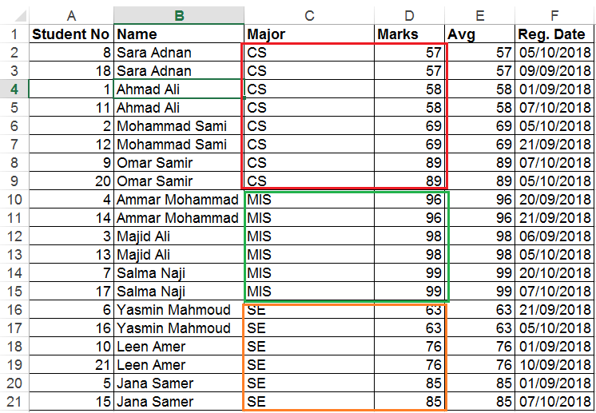

- Filtering:
Filtering is used to change the size of displayed data according to certain conditions.
To add a filter to your table select this option:
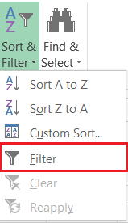
The filter icons will be displayed on each column on the table:
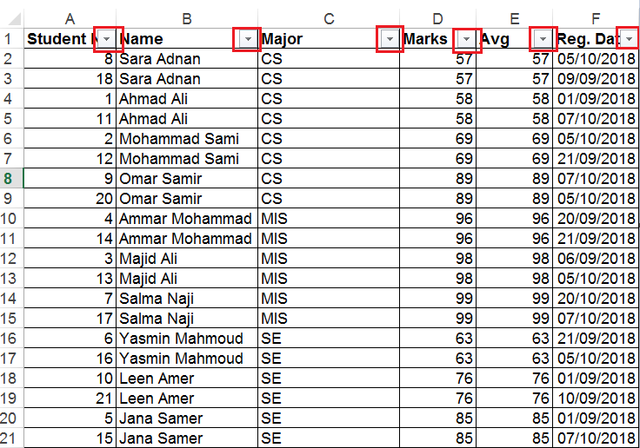

To press any filter, it will work according to the column selected.
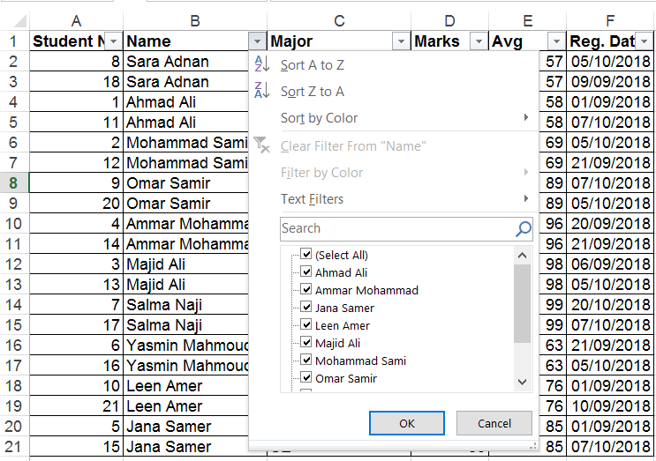
From this window, you can:
- Sort the table according to "Name", from "A to Z" or "Z to A".
- Select the names that you want to appear in the dialogue.
- Add conditions to the data displayed.
Conditions (filters) added differ according to the data type of the column selected. i.e. there are special filters for "Text", special filters for "Number" and special filters to "Date".
Text Filters:
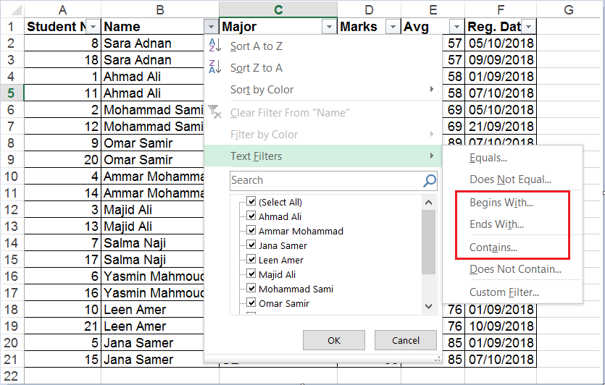
Begins With: Gets all records with Name starts with a certain text.
Ends With: Gets all records with Name ends with a certain text.
Contains: Gets all records with Name ends contains a certain text.
Ex: if "contains" is Selected, the following dialogue will appear, Enter the text "ma", in the box, when OK is pressed, the names of students that contain "ma" in the name will appear only.
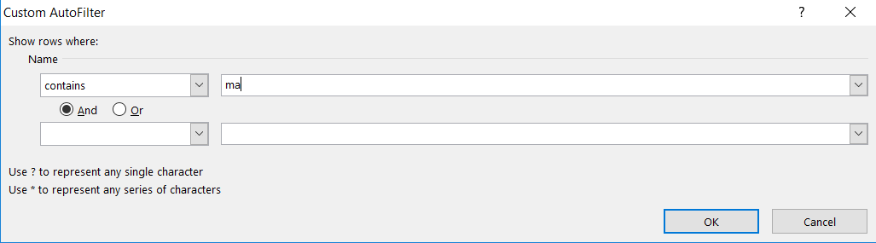
The result:
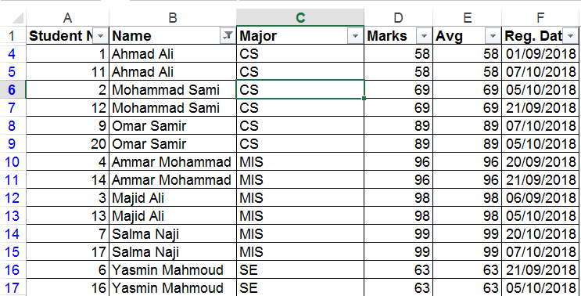
Check the filter sign that appeared next to the name which means that a filter condition was applied on the name.

Number Filters:
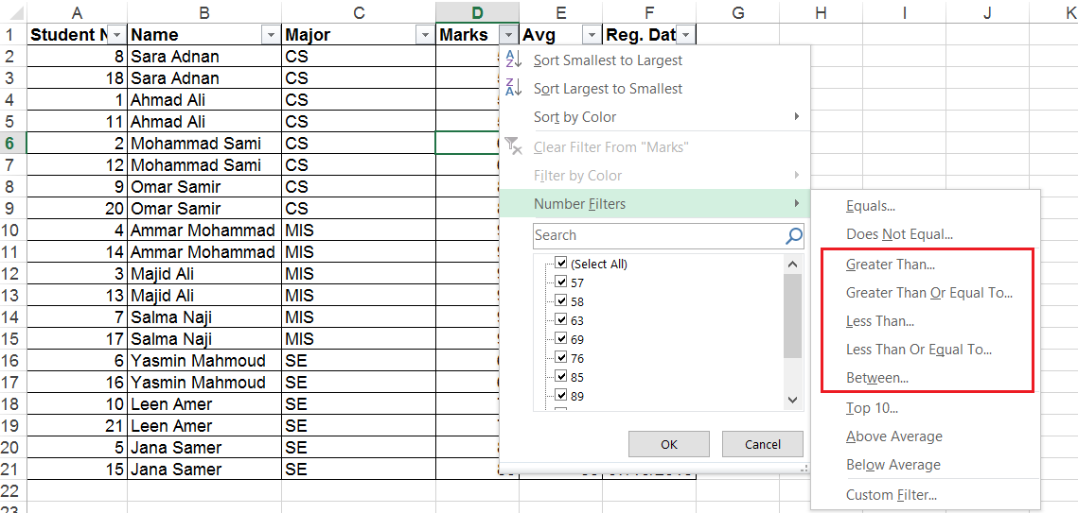
These are the conditions that you can apply on number columns:
Greater than: gets all marks that are greater than a specified number.
Greater than or Equal to: gets all marks that are greater or equal to a specified number.
Less than: gets all marks that are less than a specified number.
Less than or Equal to: gets all marks that are less or equal to a specified number.
Between: gets all marks that are between two specified numbers.
Date Filters:
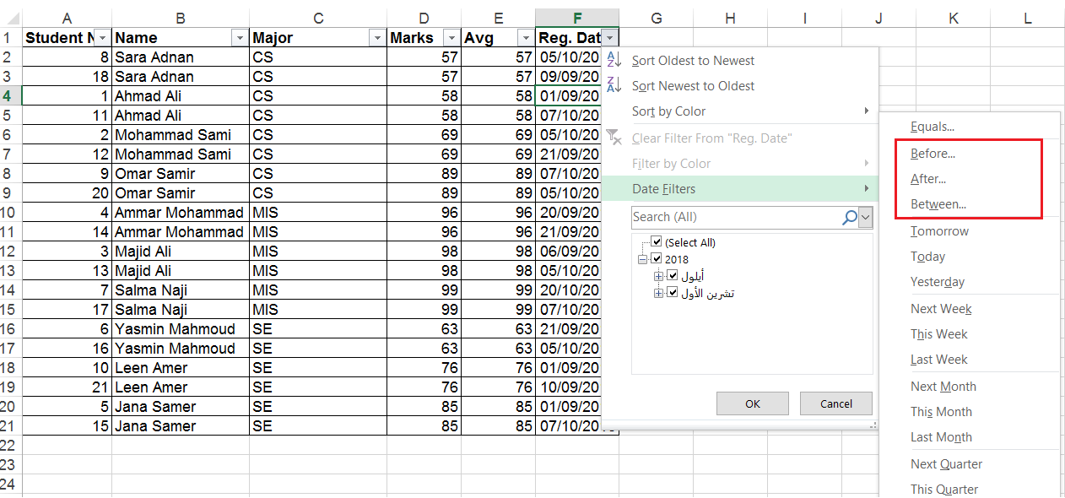
Before: Gets the records where the Reg. Dates are before a specified date.
After: Gets the records where the Reg. Dates are after a specified date.
Between: Gets the records where the Reg. Dates are between two specified dates.

Third: Advanced Searching Techniques on Excel
- VLOOKUP Function:
This function allows you to specify a column and a value, and will return a value from the corresponding row of a different column. Two examples where you might do this are looking up a student’s last name by their student number or finding a phone number by specifying a last name. Here’s the syntax of the function:
=VLOOKUP([lookup_value], [table_array], [col_index_num], [range_lookup])

[Lookup_value]: Is the value that you depend on when searching
[table_array]: The range of cells that contain the data, starting from the column you are searching from.
[col_index_num]: the number of the column where the value is searched, corresponding to the column that contains the Lookup_value.
[range_lookup]: usually make sure to make it 0, to get correct result.

Example1:
From the previous table, I need to retrieve the mark of the student "Majid Ali":
=VLOOKUP("Jana Samer";B1:C11;2; 0)
Example2: Retrieve the Mark of the student of number 7:
=VLOOKUP(7;A1:C11; 3; 0)
Example3: Retrieve the Name of the student of number 5:
=VLOOKUP(5; A1:B11; 2; 0)
Important Notes:
A few things are good to remember when you’re using VLOOKUP. First, make sure that the first column in your range is the one that includes your lookup value. If it’s not in the first column, the function will return incorrect results. If your columns are well organized, this shouldn’t be a problem.
The second thing to keep in mind is that VLOOKUP will only ever return one value. If we’d used “Georgia” as the lookup value, it would have returned the score of the first student from Georgia, and given no indication that there are in fact two students from Georgia.
- HLOOKUP Function:
Where VLOOKUP finds corresponding values in another column, HLOOKUP finds corresponding values in a different row. Because it’s usually easiest to scan through column headings until you find the right one and use a filter to find what you’re looking for, HLOOKUP is best used when you have really big spreadsheets or you’re working with values that are organized by time. Here’s the syntax:

=HLOOKUP([lookup_value], [table_array], [row_index_num], [range_lookup])
[lookup_value], again, is the value that you know and want to find a corresponding value for. [table_array] is the cells in which you want to search.
[row_index_num] specifies the row that the return value will come from.
And [range_lookup] is the same as above;

Example:
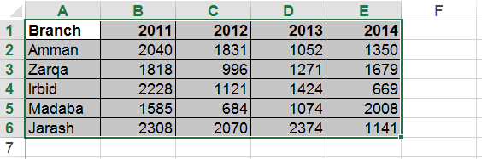
From the previous table, retrieve the sales of Madaba branch on the year 2011.
=HLOOKUP(2011; B1:B6; 5; 0)

Notes:
As with VLOOKUP, the lookup value needs to be in the first row of your table array; this is rarely an issue with HLOOKUP, as you’ll usually be using a column title for a lookup value. HLOOKUP also only returns a single value.

- INDEX Function

The INDEX function is the opposite of the MATCH function and is similar to VLOOKUP. You tell the function what row and column of the data you want, and it tells you the value of what’s in the cell.
Syntax
The syntax of the INDEX function is:
=INDEX(data range, row number, [column number])

The arguments are:
Data range. Just like the other two functions, this is the table of data.
Row number. The row number of the data, which is not necessarily the row of the worksheet. If the table range starts on row 10 of the sheet, then that’s row #1.
Column number. The column number of the data range. If the range starts on column E, that’s column #1.

- MATCH Function
The MATCH function is doesn’t return the value of data to you; you provide the value that you’re looking for, and the function returns the position of that value. It’s like asking where is #135 Main Street, and getting the answer that it’s the 4th building down the street.

Syntax
The syntax of the MATCH function is:

=MATCH(lookup value, table range, [match type])

The arguments are:

Lookup value. The cell that has the unique identifier.
Table range. The range of cells you’re searching.
Match type: 0 for perfect match.

Forth: Using Pivot Tables:
Pivot tables are one of Excel's most powerful features. A pivot table allows you to extract the significance from a large, detailed data set.
Our data set consists of 213 records and 6 fields. Order ID, Product, Category, Amount, Date and Country.
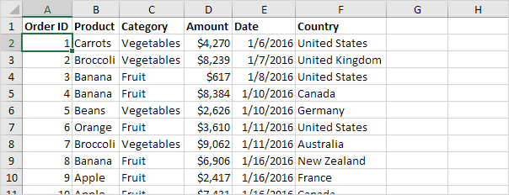

Insert a Pivot Table
To insert a pivot table, execute the following steps.
1. Click any single cell inside the data set.
2. On the Insert tab, in the Tables group, click PivotTable.
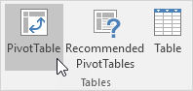
The following dialog box appears. Excel automatically selects the data for you. The default location for a new pivot table is New Worksheet.
3. Click OK.
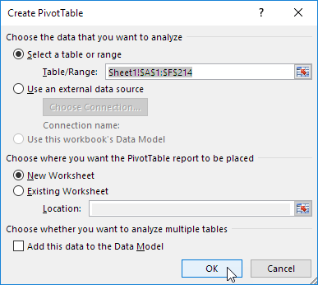

Drag fields
The PivotTable Fields pane appears. To get the total amount exported of each product, drag the following fields to the different areas.
1. Product field to the Rows area.
2. Amount field to the Values area.
3. Country field to the Filters area.
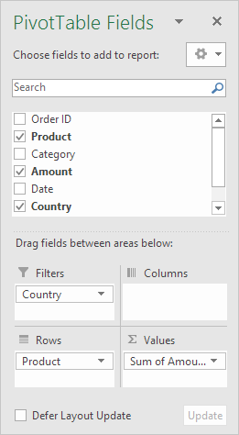
Below you can find the pivot table. Bananas are our main export product. That's how easy pivot tables can be!
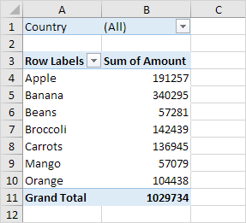

Sort
To get Banana at the top of the list, sort the pivot table.
1. Click any cell inside the Sum of Amount column.
2. Right click and click on Sort, Sort Largest to Smallest.
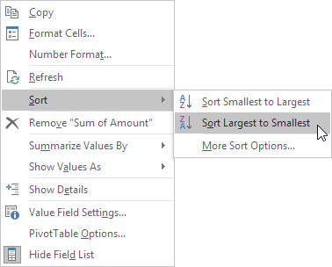
Result.
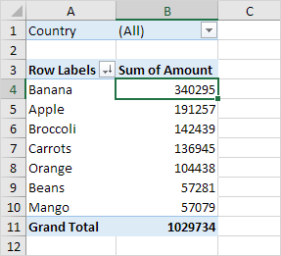

Filter
Because we added the Country field to the Filters area, we can filter this pivot table by Country. For example, which products do we export the most to France?
1. Click the filter drop-down and select France.
Result. Apples are our main export product to France.
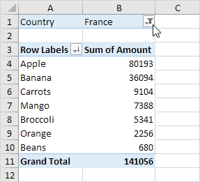
Note: you can use the standard filter (triangle next to Row Labels) to only show the amounts of specific products.

Change Summary Calculation
By default, Excel summarizes your data by either summing or counting the items. To change the type of calculation that you want to use, execute the following steps.
1. Click any cell inside the Sum of Amount column.
2. Right click and click on Value Field Settings.
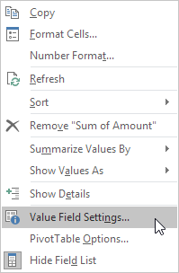
3. Choose the type of calculation you want to use. For example, click Count.
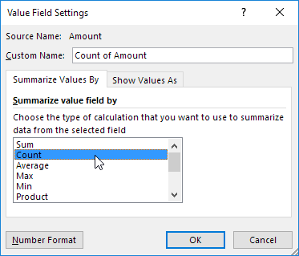
4. Click OK.
Result. 16 out of the 28 orders to France were 'Apple' orders.
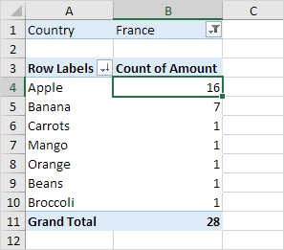

Two-dimensional Pivot Table
If you drag a field to the Rows area and Columns area, you can create a two-dimensional pivot table. First, insert a pivot table. Next, to get the total amount exported to each country, of each product, drag the following fields to the different areas.
1. Country field to the Rows area.
2. Product field to the Columns area.
3. Amount field to the Values area.
4. Category field to the Filters area.
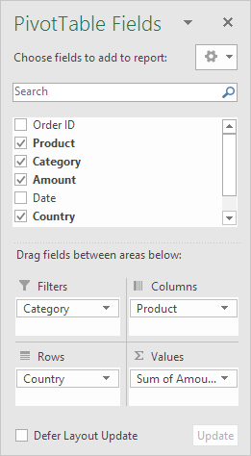
Below you can find the two-dimensional pivot table.
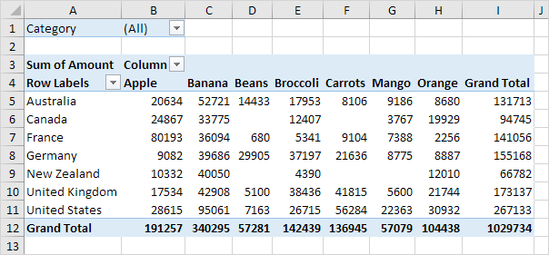
To easily compare these numbers, create a pivot chart and apply a filter. Maybe this is one step too far for you at this stage, but it shows you one of the many other powerful pivot table features Excel has to offer.
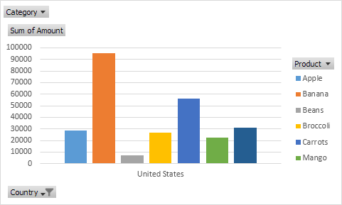

References
https://www.makeuseof.com/tag/find-anything-excel-spreadsheet-lookup-functions/
https://computers.tutsplus.com/tutorials/how-to-extract-data-from-a-spreadsheet-using-vlookup-match-and-index--cms-20641
https://exceljet.net/things-to-know-about-excel-pivot-tables
https://www.excel-easy.com/data-analysis/pivot-tables.html

